1. 
2. A person standing on a sidewalk

   Description automatically generated
3. 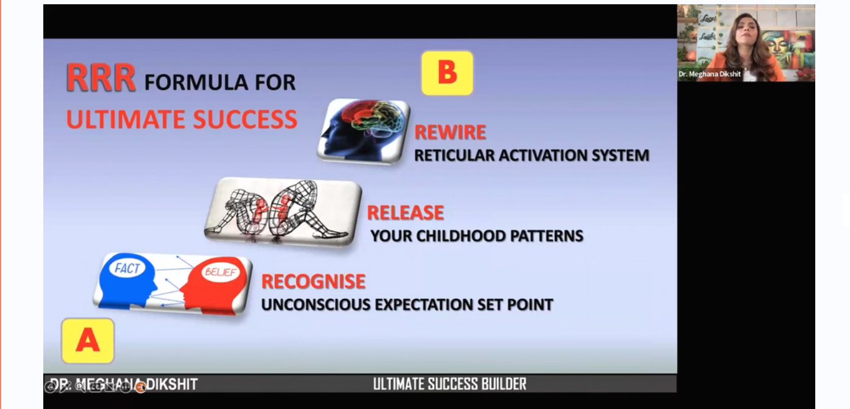
4. 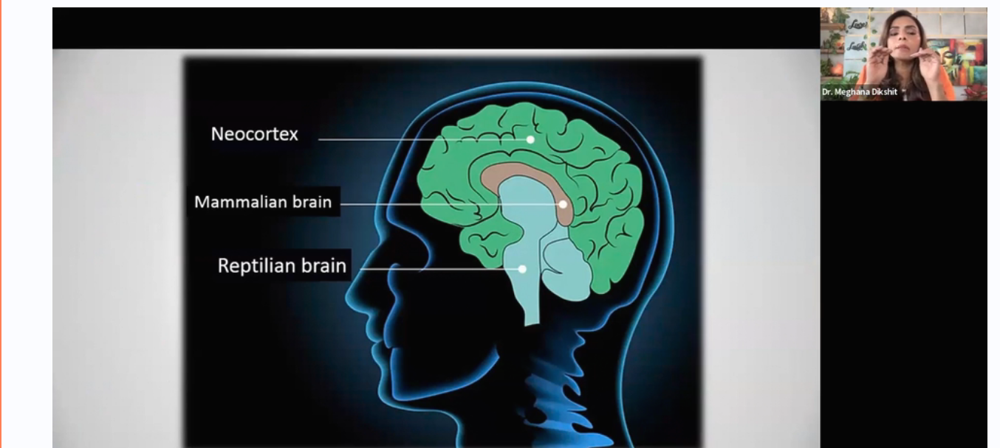A diagram of a mind

   Description automatically generated with medium confidence
5. 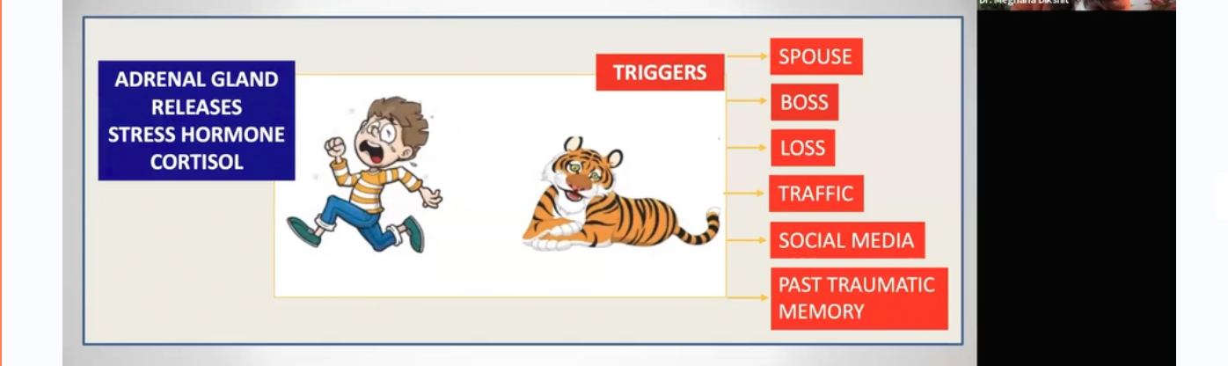A screenshot of a computer screen

   Description automatically generated
6. A close-up of a person's foot

   Description automatically generatedA screenshot of a computer

   Description automatically generated
7. A close-up of a person's foot

   Description automatically generated